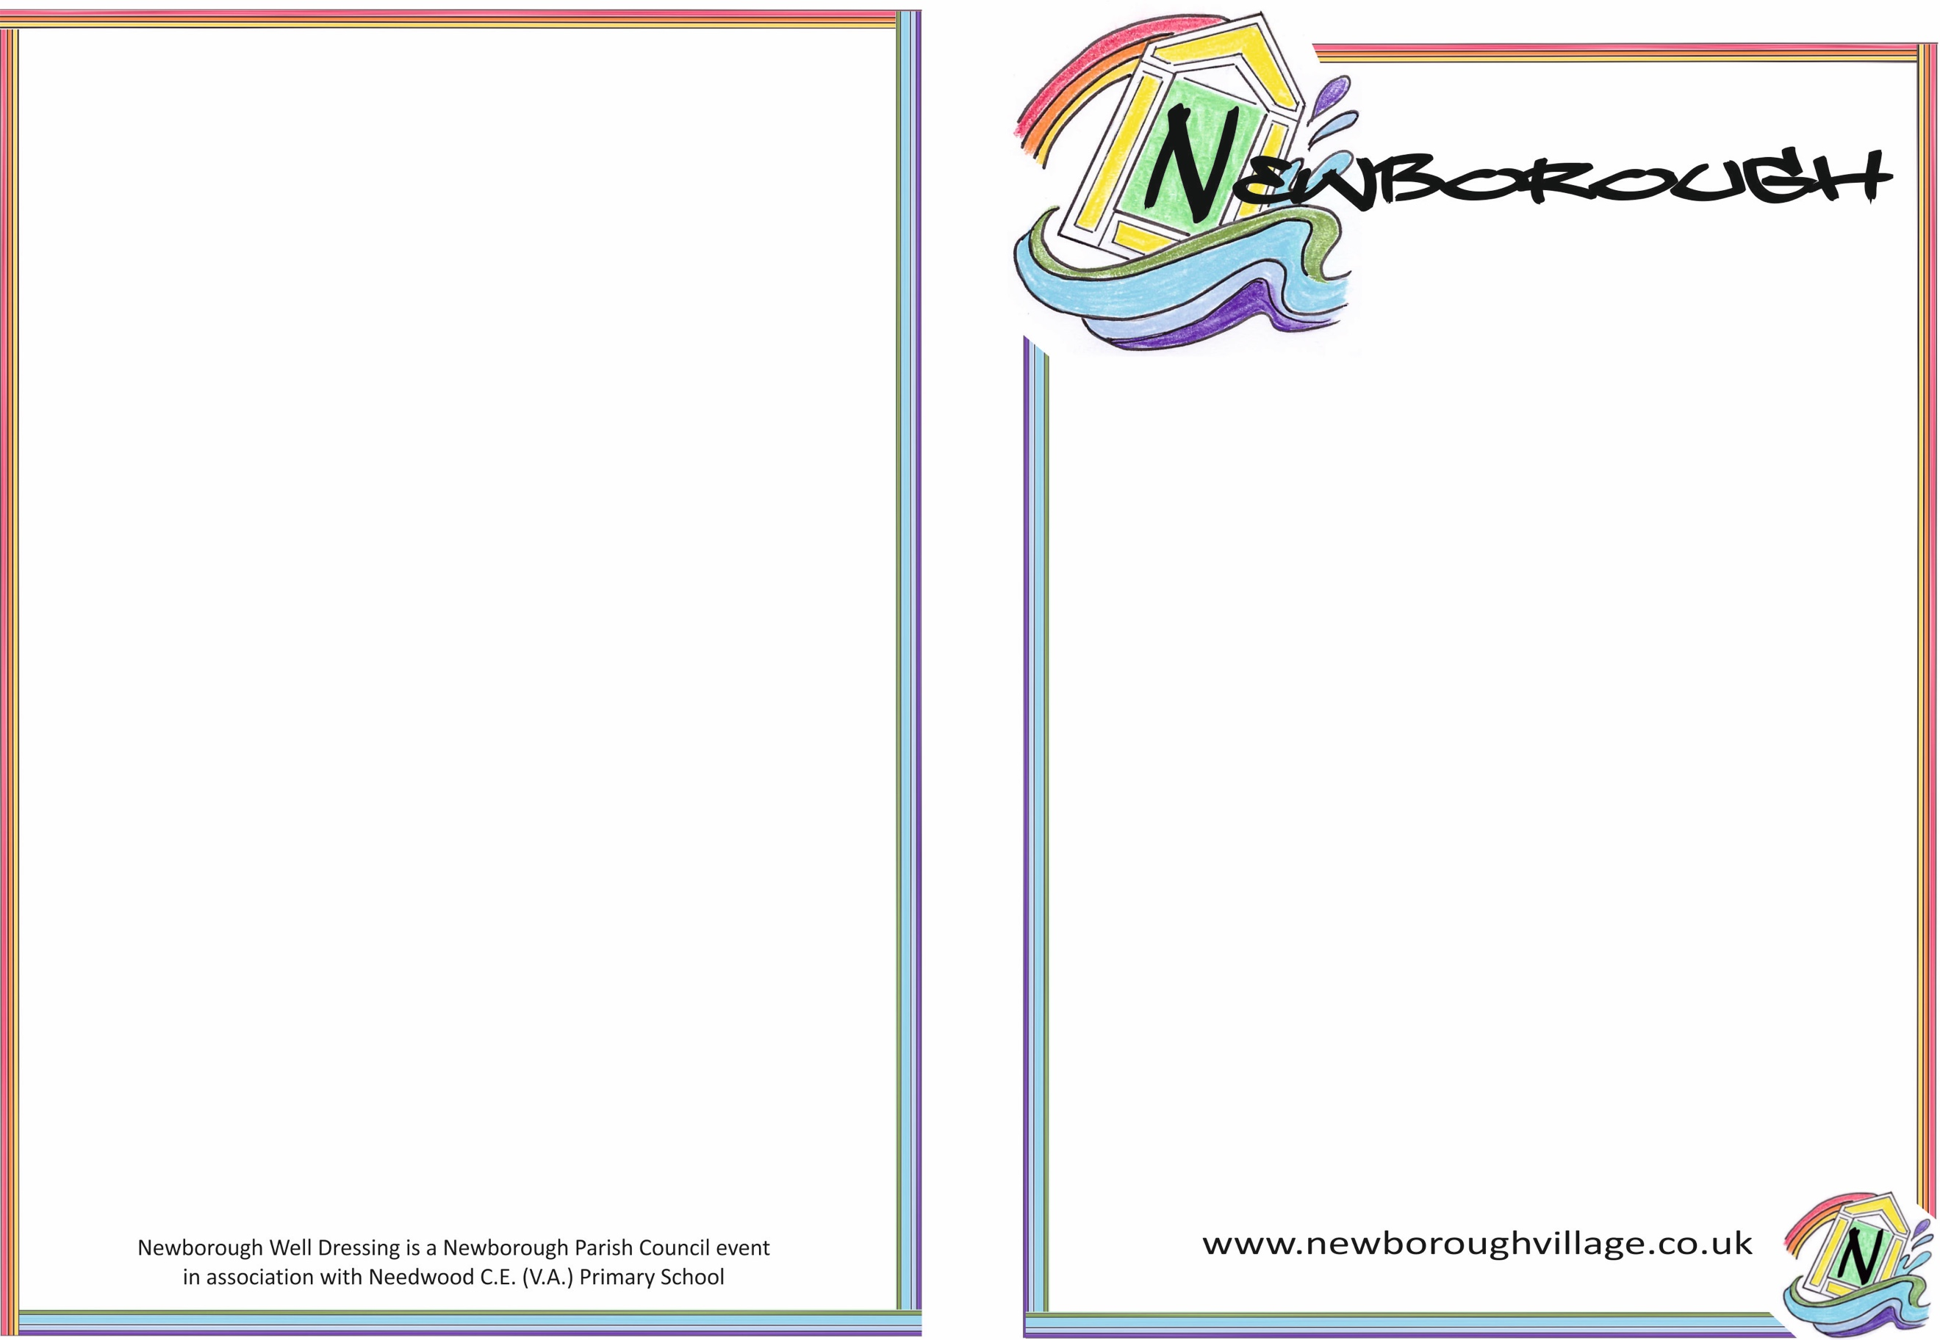

**May-Day Event**

**Well Dressing Committee meeting**

**Monday 24**th **January 2022 9.30am**

Present:

June Bullingham

Sharon Harbridge

Alison Fernyhough

Deborah Proctor

Chris Hayes (via Zoom)

Volunteer expression of interest forms

Discussion regarding the returned volunteer forms. Five had been handed into the Coffee Shop, zero to the Pub and four email replies had been received. Of the interest shown, it was estimated that 46 hours of assistance had been kindly offered by local residents for the crucial petalling week.

It had previously been established that an estimated minimum of 220 volunteer petalling hours would be required to produce the Well Boards during the week leading up to the event. Whilst we were never likely to get sufficient expressions of interest to cover the 220 hours, given that we received less than one quarter of this, we clearly do not have enough expressions of volunteer help to enable us to proceed with well dressing in 2022.

Newborough May-Day Event is a Newborough Parish Council event in association with Needwood C.E. (V.A) Primary School

**May-Day Event**

Decision

A unanimous decision was made not to go ahead with a Well Dressing event in 2022. This is essentially due to the lack of general assistance offered but also focussing on the huge challenge it would be to make this event happen with only the existing small team of volunteer committee members who in the main, have not previously been involved in the designing and producing of complicated well boards.

A message to inform residents of this decision and to give thanks to those who offered their time will go out in the Newborough News and on the village website shortly. It is hoped that next year, with more time to plan and possibly more certainty over Covid, that a Well Dressing event may go ahead.

We propose the Parish Council send the following communication to Bethan for inclusion in Newborough News and publish it on the Village Website. The Parish Council may wish to amend this communication to mention the Jubilee event.

*We'd like to express our sincere thanks to everybody who did respond to our request for help, however unfortunately we simply did not get enough offers of help to enable us to go ahead with Well Dressing in 2022. Hopefully we will be able to try again for a return of Newborough Well Dressings in 2023.*

*Newborough Well Dressing Committee*

No date for next meeting agreed at this stage.