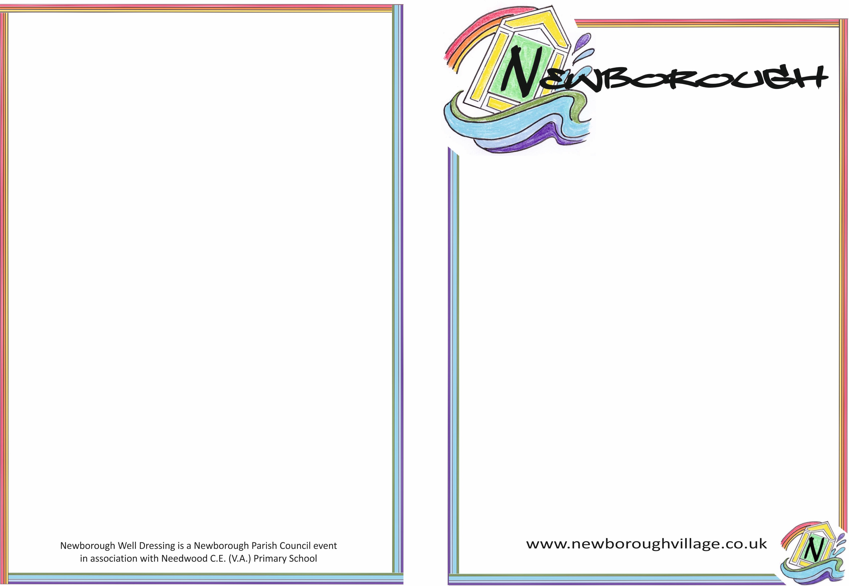

**Newborough Well dressing meeting**

Wednesday 15th Dec 2022

Present:

Sharon Harbridge

Chris Hayes (Chair)

Deborah Proctor

Apologies:

June Bullingham

Alison Fernyhough

**Discussion:** The process of making the Well Boards. Anna has provided a very detailed document detailing the entire process. This should prove extremely useful should we wish to progress with a Well Dressing event.

**Decision:** To request early assistance for the Well Dressing event with reference to puddling, petalling and general tasks in the weeks leading up to the event. We will achieve this by completing a leaflet drop around the village asking for expressions of interest.

**Action: To discuss with Nick the process of printing leaflets as he arranged the recent Parish Post leaflet. Chris**

**Action: Funding for leaflets. Discuss with Chair of Parish Council Paul Fernyhough about Parish Council funding for leaflets. Chris**

**Action: Provide wording for the leaflet by Fri 17th Dec and send to Chris for final draft and group approval. All**

**Discussion:** 220hrs is the average amount of hours of work it takes to complete the Well Boards during petalling week. We need help!

**23rd April 2022** - Put Marquee up in Bob’s field and Puddling and well board smoothing.

**25th April – 30th April 2022** – Petalling week. Volunteer request to contain following 3 options: Can you help for a couple of hours during the week, couple of hours a day or everyday - all hours….actual wording tbc. Help especially required on the Thursday, Friday and Saturday of petalling wee

**Sunday 1st May** …boards to be put out around the village. – heavy lifting and placing

**May Day 2ND May**….Stewards required to help on the day for an hour or two.

**Date for Next meeting 10am Wed 12th Jan 2022 at Brook House.**

**May-Day Event**

Initial volunteer roles and dates to be included on the leaflet:

**23rd April 2022** - Put Marquee up in Bob’s field and puddling and well board smoothing.

**25th April – 30th April 2022** – Petalling week. Volunteer request to contain following 3 options: Can you help for a couple of hours during the week, couple of hours a day or everyday - all hours tual wording tbc. Help especially required on the Thursday, Friday and Saturday of petalling wee

**Sunday 1st May** – Well boards to be put up around the village – heavy lifting and placing

**May Day 2ND May** - Stewards required to help on the day for an hour or two.

**Date for Next meeting 10am Wed 12th Jan 2022 at Brook House.**

Newborough May-Day Event is a Newborough Parish Council event in association with Needwood C.E. (V.A) Primary School

**May-Day Event**